# Internship Report

### On

Responsive Web Design

***In partial fulfillment of requirements for the degree Of***

**Bachelor of Technology**

In

**Computer Science & Engineering (Artificial Intelligence)**

**Submitted By:**

#### Mr. Raunak Batra

##### 2101331520107

**B. Tech CSE(AI) 3rd Year**

**ACSE0559 Internship Assessment-II**

#### Under the Guidance of:

**Mr.Yaduvir Singh**

**(Assistant Professor, Department of CSE(AI))**



DEPARTMENT OF COMPUTER SCIENCE AND ENGINEERING

(Artificial Intelligence)

**NOIDA INSTITUTE OF ENGG. & TECHNOLOGY, GREATER NOIDA, GAUTAM BUDDH NAGAR**

**(AN AUTONOMOUS INSTITUTE)**

**(Approved by AICTE and affiliated to Dr.A.P.J.Abdul Kalam Technical University, Uttar Pradesh, Lucknow)**

**2023**

## Certificate

I hereby certify that the work which is being submitted in the Project Report entitled **“Responsive Web design”** in partial fulfillment of the requirements for the award of the **Bachelor of Technology** in **Computer Science and Engineering Artificial Intelligence** and submitted to the Department of Computer Science & Engineering **Artificial Intelligence**, ***Noida Institute of Engineering & Technology, Greater Noida*** is an authentic record of my Internship carried out during Forth/Fifth semester under the supervision of ***Yaduvir Singh*(Assistant Professor),** Department of Computer Science and Engineering **Artificial Intelligence** , ***Noida Institute of Engineering & Technology, Greater Noida***. The matter embodied in this project Report is original and has not been submitted for the award of any other degree or diploma.

Signature of Candidate

Raunak Batra

This is to certify the above statement made by the candidate is correct and true to the best of my knowledge*.*

***Signature of Supervisor Signature of HOD***

**Yaduvir Singh Dr. Priyanka Chandani**

(Assistant Professor) (Associate Professor)

##### DECLARATION

I hereby declare that this submission is my own project and that, to the best of my own knowledge and belief, it contains no material previously published by another person nor material which to a substantial extent has been accepted for the award of any other degree or diploma of the university or other institute of higher learning except where due acknowledgement has been made in the text.

**Signature of Candidate**

**Acknowledgement**

Successfully completing any task gives us satisfaction as well as internal strength for future problems but the person alone has never existed. He is truly accompanied by few people. They use to give the person support as well as suggestion to successfully complete the work. So I feel pleasure for thanking all such great people who motivates me and provides me kind support at all stages of my Internship Project work.

Firstly, I would like to honor my institute *“****Noida Institute of Engineering & Technology, Greater Noida****”.* Here I have been provided with a workplace and infrastructure to learn recent technologies and conceptual background to strengthen my programming and professional skills.

I am very much grateful to **Mr.Yaduvir Singh ,Assistant Professor (Computer Science and Engineering Artifical Intelligence) and *Dr.*Priyanka Chandani *(Associate Professor & Head,* Computer Science and Engineering Artificial Intelligence*), Noida Institute of Engineering & Technology, Greater Noida*,** for her helpful attitude and encouragement in making my project.

Furthermore, I am thankful to, all faculty members for motivating me and to the ***Staffs of computer labs*** in the department for providing excellent valuable facility as well as issuing me a computer system of good configuration and providing regular maintenance.

I would like to extend special thanks to all my batch mates for their love, encouragement and constant support.

Last but not least I would like to thank my parents for supporting me to complete my project report in all ways.

Raunak batra

#### Table of Contents

|  |  |  |
| --- | --- | --- |
| **S. No.** | **TITLE** | **Pg No.** |
| 1. | Internship Certificate |  |
| 2. | Abstract |  |
| 3. | Technology Background |  |
| 4. | Project Problem Background |  |
| 5. | Project Modules |  |
| 6. | Snapshots of project |  |
| 7. | Applications |  |
| 8. | Reference |  |

#### Internship Certificate

#### Abstract(with respect to the Topic)

Responsive Web Design (RWD) is a crucial aspect of modern web development, ensuring that web applications render well on a variety of devices and window or screen sizes. This report delineates the comprehensive training and practical experience gained during an internship focused on RWD, facilitated by freeCodeCamp. The internship's primary objective was to master the principles of RWD and apply them in designing web pages that provide an optimal viewing experience—easy reading and navigation with a minimum of resizing, panning, and scrolling—across a wide range of devices.

Throughout the internship, a methodical approach was adopted involving the rigorous study of CSS and HTML, the fundamental technologies used in RWD. Key topics such as media queries, flexible grid-based layouts, and adaptive images were covered. The hands-on experience was gained through the development of various projects that included creating responsive templates, navigation bars, and image galleries, all adhering to the best practices of RWD.

The outcomes of the internship are evident in the multiple responsive websites that were successfully designed, showcasing a solid understanding of responsive design principles and the ability to implement user-friendly interfaces. The report concludes with reflections on how these skills will be instrumental in addressing the dynamic requirements of web design and development in a multi-device internet landscape.

This abstract gives an overview that should guide the reader on what to expect in your report, outlining your learning journey and the practical skills you acquired during your internship. When drafting your report, you should expand on each point in the abstract to provide a full narrative of your experience and insights.

#### Technology Background

Responsive Web Design (RWD) represents a fundamental shift in how websites are constructed and viewed. It is a design approach aimed at crafting sites to provide an optimal viewing and interaction experience across a wide range of devices, from desktop computer monitors to mobile phones.

* **HTML and CSS**: The foundation of web content structure and style, enabling the creation of responsive layouts.
* **Media Queries**: CSS3 feature allowing the application of different styles for different devices, crucial for adapting layouts to various screen sizes.
* **Fluid Grids**: Design strategy using relative units for layout elements, ensuring flexibility and adaptability of the web page layout to different screen resolutions.
* **Flexible Images**: Technique to make images scale with the layout elements, using CSS or SVG formats, to prevent them from distorting on different devices.
* **Responsive Frameworks**: Tools like Bootstrap and Foundation offer pre-designed responsive components that expedite the development process.
* **Mobile-First Approach**: Design strategy prioritizing mobile device compatibility, reflecting the increased mobile internet usage.
* **Search Engine Adaptation**: Initiatives like Google's mobile-first indexing prioritize mobile-friendly web content in search results.
* **Accessibility**: Ensuring web content is usable for all people, regardless of device or other potential restrictions.

#### Project Problem Background

* **Cross-Device Compatibility**: Ensuring websites function seamlessly across diverse devices with varying screen sizes and resolutions.
* **User Experience**: Addressing the need for a consistent and intuitive user interface irrespective of the device being used.
* **Changing Usage Patterns**: Adapting to the shift in user behavior as internet consumption on mobile devices surpasses that on desktops.
* **High Maintenance Costs**: Combating the inefficiency of managing multiple versions of a website for different devices.
* **Search Engine Optimization**: Meeting the requirements of modern search engines that favor mobile-friendly websites.
* **Load Times and Bandwidth**: Improving website performance in terms of load times, especially on mobile networks with bandwidth limitations.
* **Future Scalability**: Designing websites that are easily scalable for future devices and screen sizes without the need for complete redesigns.
* **Accessibility Standards**: Ensuring web content is accessible to all users, including those with disabilities, across different devices.

#### Project Modules

* **Module 1: Responsive Layouts**
  + Creation of flexible grid systems.
  + Implementation of CSS Flexbox for responsive modules.
  + Design of responsive navigation menus.
* **Module 2: Media Queries**
  + Use of breakpoints for different screen sizes.
  + Conditional CSS for device-specific styling.
  + Techniques for landscape vs. portrait orientation adjustments.
* **Module 3: Typography and Readability**
  + Scalable font sizes using relative units (em, rem).
  + Line-height and spacing for improved readability on small screens.
  + Font-face implementation for cross-device font consistency.
* **Module 4: Images and Media**
  + Techniques for flexible images that avoid distortion.
  + Use of CSS techniques and HTML attributes for responsive media embedding.
  + Exploration of SVG for resolution-independent graphics.
* **Module 5: Performance Optimization**
  + Strategies for minimizing load times (e.g., image compression, CSS minification).
  + Implementation of lazy loading for media assets.
  + Techniques for reducing HTTP requests.
* **Module 6: Testing and Debugging**
  + Use of developer tools for responsive testing.
  + Cross-browser and cross-device testing workflows.
  + Debugging common responsive design issues.
* **Module 7: Frameworks and Tools**
  + Introduction to Bootstrap or Foundation for rapid prototyping.
  + Use of responsive design templates.
  + Customization of framework components.

#### Snapshots

So these were Projects that we need to be done to earn Certificate:-

* Build a Survey Form
* Build a Tribute Page
* Build a Technical Documentation Page
* Build a Product Landing Page
* Build a Personal Portfolio Webpage

So these are Snapshots of some of the Results: -

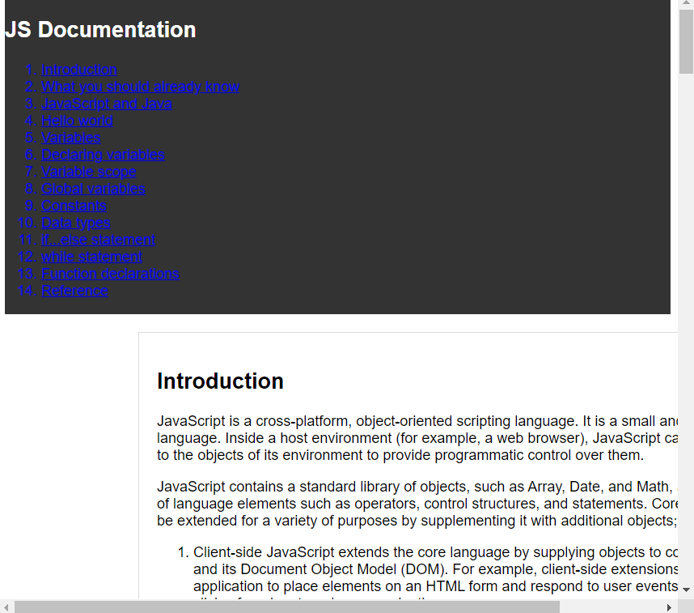

**Self-Made Project on this**

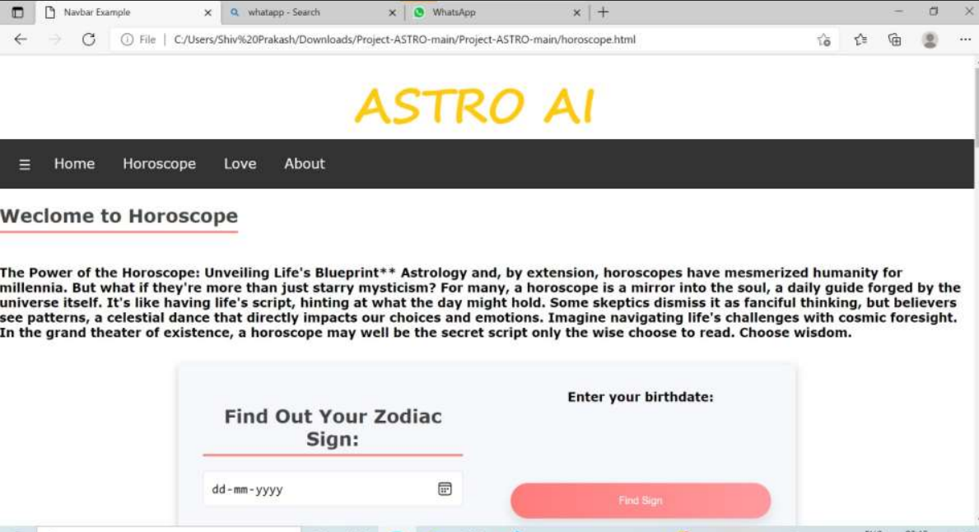

#### Application

* **Optimizing Existing Websites**: Retrofitting non-responsive sites to make them mobile-friendly and comply with modern web standards.
* **New Website Development**: Applying RWD principles from the ground up in the creation of new websites to ensure cross-device compatibility.
* **E-commerce Platforms**: Designing responsive online stores that offer an optimal shopping experience on any device, potentially increasing conversion rates.
* **Content Management Systems (CMS) Themes**: Creating or modifying CMS themes, like those for WordPress, to be responsive, catering to a broader audience.
* **User Interface (UI) Kits**: Developing UI kits with responsive components that can be reused in various web projects to streamline design processes.
* **Email Templates**: Crafting responsive email templates that render effectively on desktop clients and mobile devices, ensuring communications are accessible.
* **Web Applications**: Designing web apps with responsive layouts to enhance usability and functionality across all device types.
* **Prototyping and Wireframing**: Utilizing RWD methodologies during the prototyping phase to illustrate how web projects will adapt to different screen sizes.
* **Multimedia and Advertising**: Ensuring that multimedia content and advertisements are responsive, thereby maintaining their effectiveness and avoiding layout disruptions.
* **Analytics and Reporting Dashboards**: Creating dashboards that are responsive, allowing users to access data and insights on any device without compromising on readability or functionality.
* **Educational Platforms**: Implementing responsive design in online learning environments to provide an accessible educational experience for students on tablets, smartphones, and laptops.
* **Accessibility Enhancements**: Using RWD to improve accessibility for users with disabilities, aligning with legal compliance and inclusive design principles.

#### References

* Freecodecamp : Setting up Environment and Providing Certificate <https://www.freecodecamp.org/learn/2022/responsive-web-design/>
* Firdaus, R. (2020). Building Responsive Websites with Real-World Projects. A press.

<https://doi.org/10.1007/978-1-4842-5967-4>

* For Tribute Page: - https://en.wikipedia.org/wiki/Norman_Borlaug
* Marcotte, E. (2011). Responsive Web Design. A Book Apart.
* Google Developers. (n.d.). Responsive Web Design Basics. Retrieved April 10, 2023, from https://developers.google.com/web/fundamentals/design-and-ux/responsive
* W3Schools. (n.d.). CSS Responsive. Retrieved April 12, 2023, from https://www.w3schools.com/css/css_rwd_intro.asp
* Mozilla Developer Network. (2023). Media Queries. Retrieved April 15, 2023, from https://developer.mozilla.org/en-US/docs/Web/CSS/Media_Queries/Using_media_queries
* Richardson, L. (2022). Adaptive Web Design: Crafting Rich Experiences with Progressive Enhancement (2nd ed.). Peachpit Press.
* Bootstrap Documentation. (2023). Introduction. Retrieved April 20, 2023, from https://getbootstrap.com/docs/5.0/getting-started/introduction/